**Lab plan No.1** **Name:** Muhammad Faizan **Reg No.**21-NTU-CS-1258

# Question No.1

**(a)**

## Input:

#include <iostream>

using namespace std;

int main()

{

cout <<"The most likely way for the world to be destroyed,\n Most experts agree, \'is by accident'.\n That's where we come in\n\"We're computer professionals. We cause accidents.\"";

return 0;

}

## Output:

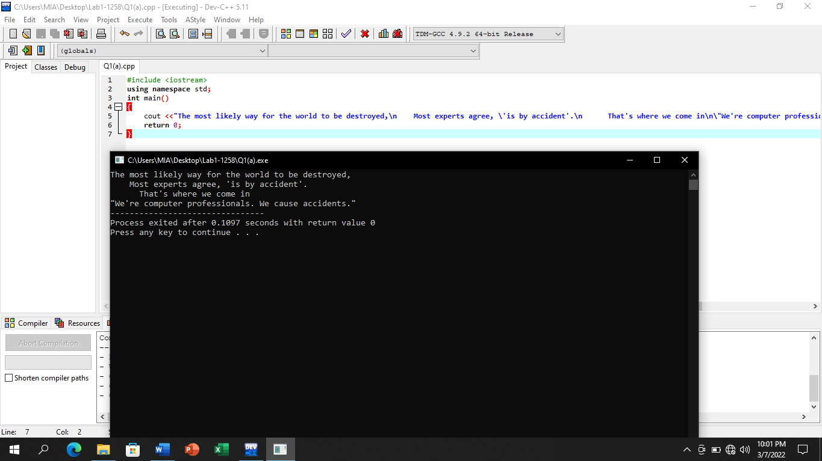

**(b)**

## Input:

#include <iostream>

using namespace std;

int main()

{

cout<<"The most likely way for the world to be destroyed,\n";

cout<<" Most experts agree, \'is by accident' .\n";

cout<<" That's where we come in;\n";

cout<<"We're computer professionals. We cause accidents.";

return 0;

}

## Output:

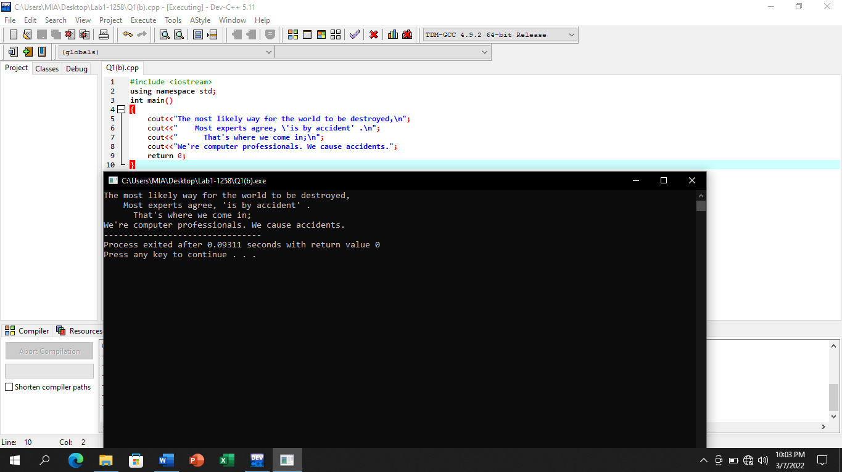

# Question No.2

**(a)**

## Input:

#include <iostream>

using namespace std;

int main()

{

cout<<"*********\n* *\n* *\n* *\n* *\n* *\n* *\n* *\n*********\n";

cout<<" *** \n * * \n* *\n* *\n* *\n* *\n* *\n * * \n *** \n";

cout<<" * \n *** \n*****\n * \n * \n * \n * \n * \n * \n";

cout<<" * \n * * \n * * \n * * \n* *\n * * \n * * \n * * \n * \n";

return 0;

}

## Output:

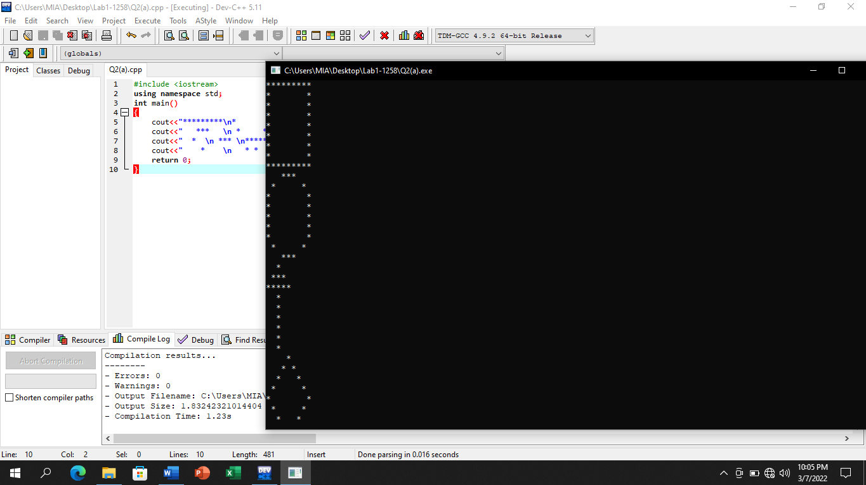

**(b)**

## Input:

**#include <iostream>**

**using namespace std;**

**int main()**

**{**

**cout<<"*********\n";**

**cout<<"* *\n";**

**cout<<"* *\n";**

**cout<<"* *\n";**

**cout<<"* *\n";**

**cout<<"* *\n";**

**cout<<"* *\n";**

**cout<<"* *\n";**

**cout<<"*********\n";**

**cout<<" *** \n";**

**cout<<" * * \n";**

**cout<<"* *\n";**

**cout<<"* *\n";**

**cout<<"* *\n";**

**cout<<"* *\n";**

**cout<<"* *\n";**

**cout<<" * * \n";**

**cout<<" *** \n";**

**cout<<" * \n";**

**cout<<" *** \n";**

**cout<<"*****\n";**

**cout<<" * \n";**

**cout<<" * \n";**

**cout<<" * \n";**

**cout<<" * \n";**

**cout<<" * \n";**

**cout<<" * \n";**

**cout<<" * \n";**

**cout<<" * * \n";**

**cout<<" * * \n";**

**cout<<" * * \n";**

**cout<<"* *\n";**

**cout<<" * * \n";**

**cout<<" * * \n";**

**cout<<" * * \n";**

**cout<<" * \n";**

**return 0;**

**}**

## Output:

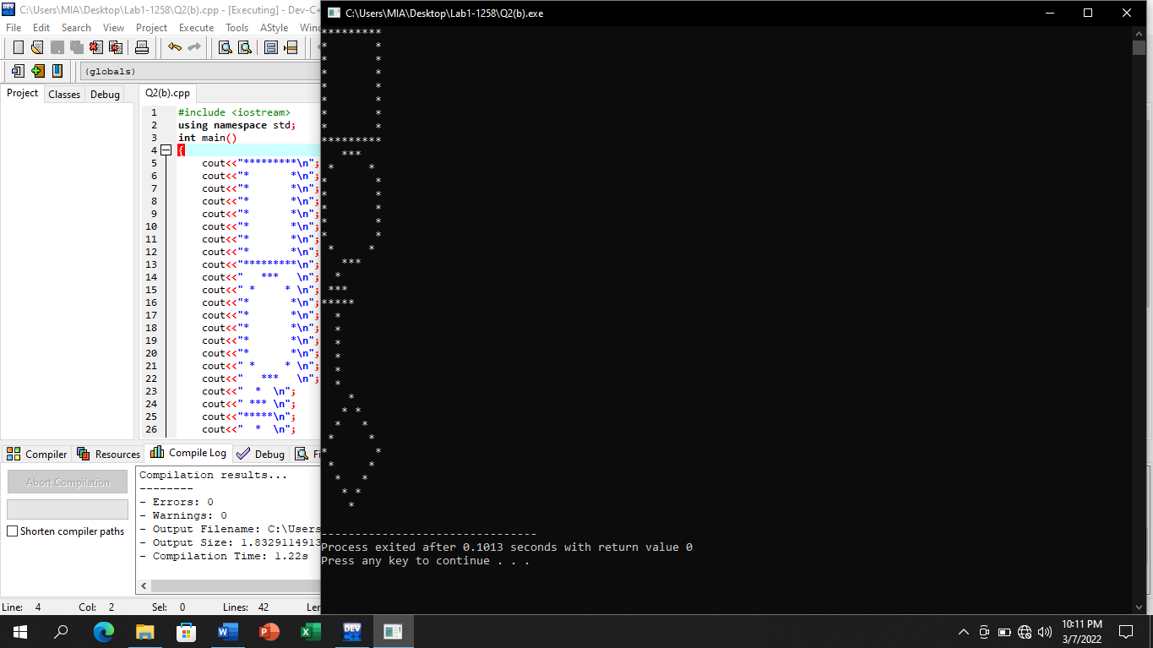

**(c)**

## Input:

## #include <iostream>

## using namespace std;

## int main()

## {

## cout<<"********* *** * * \n";

## cout<<"* * * * *** * * \n";

## cout<<"* * * * ***** * * \n";

## cout<<"* * * * * * * \n";

## cout<<"* * * * * * *\n";

## cout<<"* * * * * * * \n";

## cout<<"* * * * * * * \n";

## cout<<"* * * * * * * \n";

## cout<<"********* *** * * \n";

## return 0;

## }

## Output:

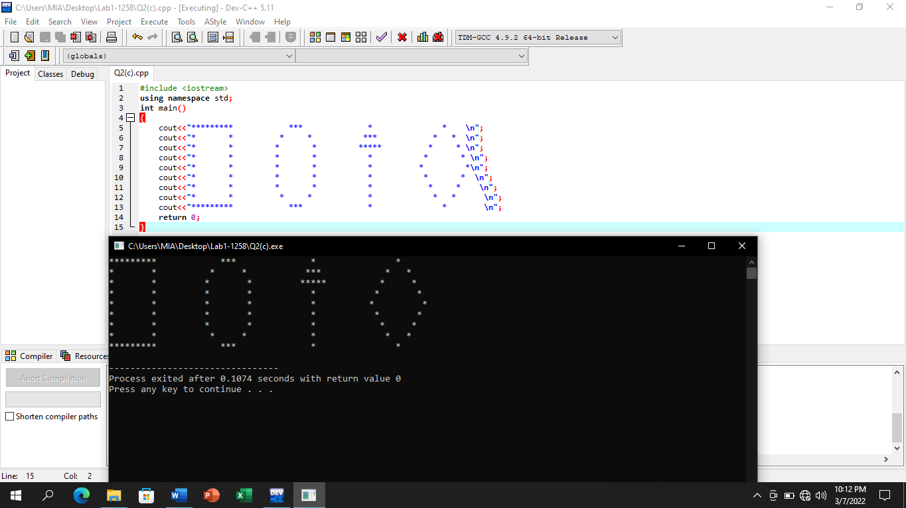

# Question No.3

## Input:

#include <iostream>

using namespace std;

int main()

{

cout<<" ***************************\n\n";

cout<<" Ali \t 21-NTU-CS-1404\n";

cout<<" Akbar\t 21-NTU-CS-1405\n";

cout<<"***************************";

return 0;

}

## Output:

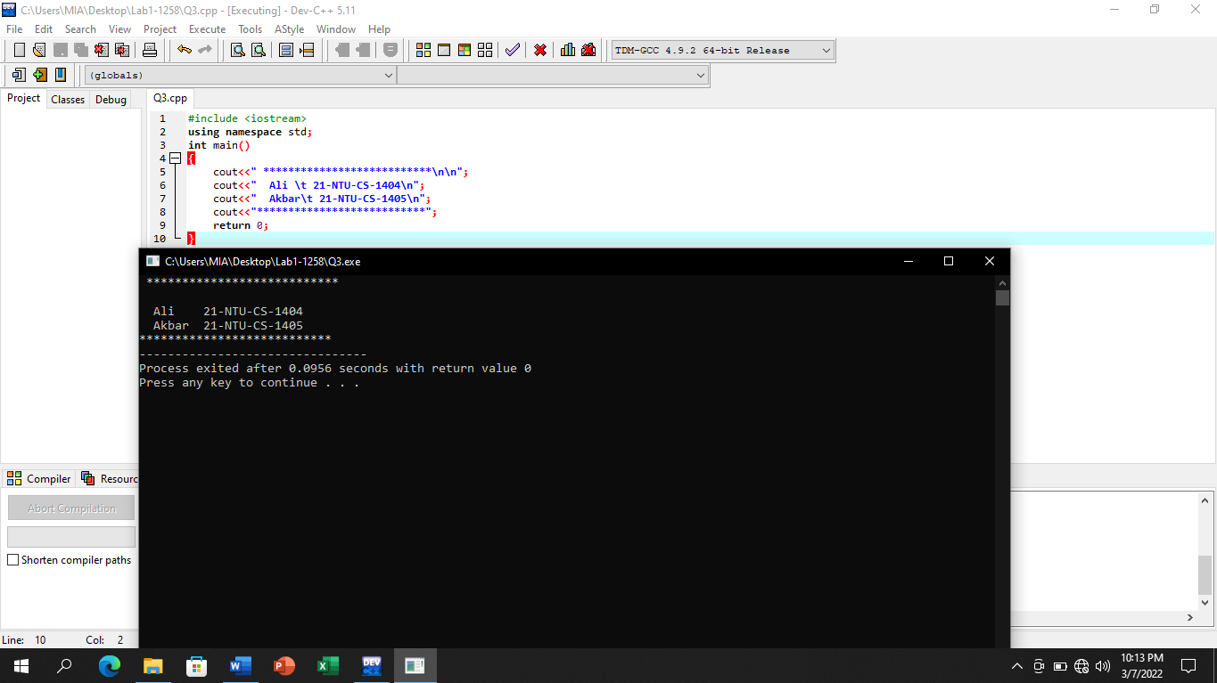

# Question No.4

## Input:

#include <iostream>

using namespace std;

int main()

{

int a=15, b=4, c=a/b;

cout<<a<<endl<<b<<endl<<c;

return 0;

}

## Output:

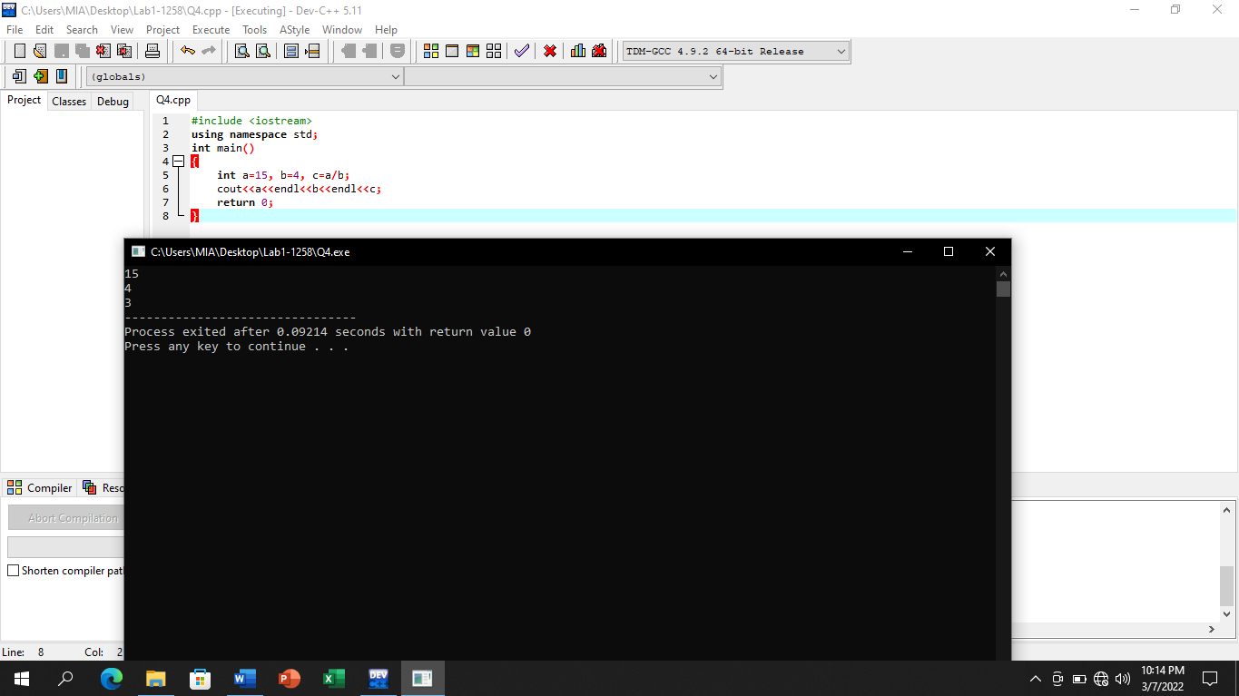

# Question No.5

## Input:

#include <iostream>

using namespace std;

int main()

{

float a=1.5, b=4.487, c=a/b;

cout<<a<<endl<<b<<endl;

cout<<c;

return 0;

}

## Output:

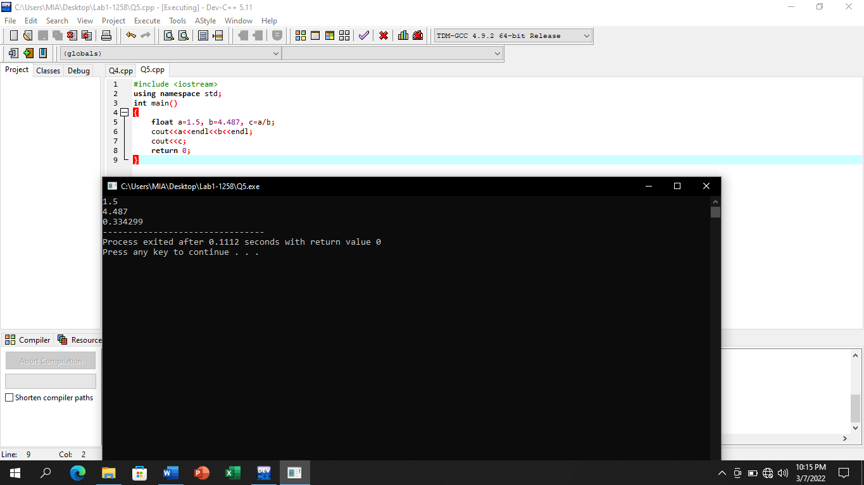

# Question No.6

## Input:

#include <iostream>

using namespace std;

int main()

{

char a='Z', b='&', c='A';

cout<<a<<endl;

cout<<b<<endl;

cout<<c;

return 0;

}

## Output:

